Software Requirements Specification
for
TradeHawk
Version 1.0

Prepared by Team 11
Group Name: DevNest
G.NIKHILESH | SE22UCSE098 | se22ucse098@mahindrauniversity.edu.in
K.KARTHIK REDDY | SE22UCSE128 | se22ucse128@mahindrauniversity.edu.in
KTS SATWIK REDDY | SE22UCSE122 | se22ucse122@mahindrauniversity.edu.in
KARTHIK KUMAR REDDY | SE22UCSE276 | se22ucse276@mahindrauniversity.edu.in
AMITH REDDY  L.ADARSH  T.HARSHDEEP  EVM TEJA | SE22UCSE266  SE22UCSE304  SE22UCSE108  SE22UCSE091 | se22ucse266@mahindrauniversity.edu.in  se22ucse304@mahindrauniversity.edu.in  se22ucse108@mahindrauniversity.edu.in  se22ucse091@mahindrauniversity.edu.in

Instructor: | Vijay Rao
Course: | Software Engineering(CS3201)
Lab Section: | CS-2
Teaching Assistant: | Sravanthi Acchugatla
Date: | 10-03-2025
Contents
Contents ii
Revisions ii
1 Introduction 1
1.1 Document Purpose 1
1.2 Product Scope 1
1.3 Intended Audience and Document Overview 1
1.4 Definitions, Acronyms and Abbreviations 1
1.5 Document Conventions 1
1.6 References and Acknowledgments 2
2 Overall Description 2
2.1 Product Overview 2
2.2 Product Functionality 3
2.3 Design and Implementation Constraints 3
2.4 Assumptions and Dependencies 3
3 Specific Requirements 4
3.1 External Interface Requirements 4
3.2 Functional Requirements 4
3.3 Use Case Model 5
4 Other Non-functional Requirements 6
4.1 Performance Requirements 6
4.2 Safety and Security Requirements 6
4.3 Software Quality Attributes 6
5 Other Requirements 7
Appendix A – Data Dictionary 8
Appendix B - Group Log 9

Revisions
Version | Primary Author(s) | Description of Version | Date Completed
Draft v1.0 | G Nikhilesh  K Karthik Reddy  KTS Satwik Reddy  EVM Teja  Harshdeep T  Amith Reddy  Adarsh Ladi  Karthik Kumar Reddy | Initial draft of the Software Requirements Specification (SRS) for TradeHawk, outlining system functionalities, use cases, and constraints based on the project scope. | 10-03-2025

Introduction

Document Purpose
This Software Requirements Specification (SRS) document outlines the functional and non-functional requirements for TradeHawk, an online auction platform developed for Mahindra University students. The platform aims to create a structured, secure, and user-friendly environment where students can buy, sell, and repurchase items through an auction-based system. The document serves as a comprehensive guide for the development team, stakeholders, and users by detailing the system’s features, constraints, and objectives.
The scope of this document focuses on defining the software requirements for the core functionalities of the auction platform, including auction listing, real-time bidding, secure transactions, user authentication, and profile management. While this SRS provides a detailed description of the platform’s primary system, it does not cover potential future extensions, such as integration with external e-commerce platforms or mobile applications.

Product Scope
TradeHawk is an online auction platform designed exclusively for Mahindra University students to facilitate the buying, selling, and repurchasing of items within their academic community. The platform provides a structured, secure, and user-friendly marketplace where students can list products, place bids, and complete transactions seamlessly. Built using modern web technologies such as React.js, Node.js, and MongoDB, TradeHawk ensures an optimized and responsive user experience with key features like real-time bidding, user authentication, advanced search filters, and personalized dashboards.
The objectives of TradeHawk include developing a robust and responsive auction platform, enabling students to list and bid on items effortlessly, and implementing secure payment and transaction features to ensure a seamless experience. The goals of this project focus on streamlining the auction process, fostering a sense of community-driven resource sharing, and providing a sustainable marketplace where students can access affordable goods. The benefits of TradeHawk include promoting sustainability by encouraging the reuse of second-hand items, reducing waste, and offering students a cost-effective alternative for purchasing essential products. Additionally, the platform ensures security and trust by restricting access to verified Mahindra University students, making transactions safe and reliable.

Intended Audience and Document Overview
This Software Requirements Specification (SRS) document is intended for multiple stakeholders involved in the development and evaluation of the TradeHawk platform. The key audiences for this document include:
- Professor Vijar Rao Sir, Avinash Arun Chauhan Sir (Instructor for Software Engineering Course at Mahindra University)
Recommended reading order:
Introduction (Section 1) – Provides an overview of the project, including its purpose and scope.
Overall Description (Section 2) – Covers the system's high-level functionality, constraints, and dependencies.
Specific Requirements (Section 3) – Details the functional and non-functional requirements of the system.
Use Case Model (Section 3.3) – Helps assess how well the system design meets real-world scenarios.
Software Quality Attributes (Section 4.3) – Provides insights into software reliability, usability, and maintainability.
- Mahindra University Students (Clients and End Users) – The primary users of the auction platform who will interact with the system for buying, selling, and bidding on items.
Recommended reading order:
Product Overview (Section 2.1) – Explains how the platform works and what features are included.
Product Functionality (Section 2.2) – Lists key functions such as auction listing, real-time bidding, and payment processing.
External Interface Requirements (Section 3.1) – Describes how users will interact with the system through the UI.
Safety and Security Requirements (Section 4.2) – Details measures ensuring secure transactions and user authentication.
- Development Team – The group responsible for designing, coding, and testing the software.
Recommended reading order:
Functional Requirements (Section 3.2) – Defines core system operations and expected behaviors.
Design and Implementation Constraints (Section 2.3) – Lists technology stacks, limitations, and dependencies.
External Interface Requirements (Section 3.1) – Describes how the front-end, back-end, and databases interact.
Non-Functional Requirements (Section 4) – Includes performance, security, and scalability requirements.

Definitions, Acronyms and Abbreviations
API: Application Programming Interface
AWS: Amazon Web Services
CS: Computer Science
DBMS: Database Management System
GDPR: General Data Protection Regulation
GUI: Graphical User Interface
HTML: Hypertext Markup Language
HTTPS: Hypertext Transfer Protocol Secure
ISO: International Organization for Standardization
JSON: JavaScript Object Notation
MFA: Multi-Factor Authentication
MongoDB: NoSQL Database used for storing auction data
MySQL: Relational Database Management System
OTP: One-Time Password
PWA: Progressive Web Application
RBAC: Role-Based Access Control
React.js: JavaScript library for building user interfaces
REST API: Representational State Transfer Application Programming Interface
SRS: Software Requirements Specification
SSL/TLS: Secure Sockets Layer / Transport Layer Security
TA: Teaching Assistant
UI: User Interface
UML: Unified Modelling Language
UX: User Experience
WCAG: Web Content Accessibility Guidelines

Document Conventions
1. Formatting Conventions

- The document follows the IEEE formatting requirements for software documentation.
- Font: Arial, size 11 used consistently throughout the document.
- Line Spacing: Single-spaced for readability and compactness.
- Margins: 1-inch margins on all sides of the document.
- Section and Subsection Titles:
  - Main section titles (e.g., 1, 2, 3) are bold and numbered.
  - Subsection titles (e.g., 1.1, 2.1.1) are also bold but in a smaller font size than main sections.

2. Typographical Conventions

- Italics: Used for comments, placeholder text, and special notes.
- Bold: Used for section headings, key terms, and important information.
- Tables and Lists:
  - Used for structured data presentation, following a clean and readable layout.
  - Numbered or bulleted lists are used to enhance readability and organization.

3. Naming Conventions
- Acronyms: Defined in the Glossary section when first introduced.
- Requirement Labels: Functional and non-functional requirements are labeled as F1, F2, P1, P2, etc. for easy reference.
- Use Case Identifiers: Each use case is labeled (e.g., U1: Login, U2: Browse Items) for tracking.

References and Acknowledgments
UML Diagrams for the Group
USECASE,SEQUENCE,CLASS DIAGRAMS

MongoDB Security Practices
https://www.mongodb.com/docs/manual/security/

Information Technology Rules, 2011
https://www.meity.gov.in/

Aadhaar Data Security Guidelines
https://uidai.gov.in/

HTML, CSS, and JavaScript Documentation
https://developer.mozilla.org/

IEEE Standard for Software Requirements Specifications (IEEE 830- 1998)

MySQL Official Documentation
https://dev.mysql.com/doc/

Overall Description

Product Overview
TradeHawk is a new, self-contained web application designed exclusively for Mahindra University students to facilitate online auctions for buying, selling, and repurchasing items within their academic community. Unlike existing generic marketplace platforms, TradeHawk is tailored specifically to student needs, ensuring a secure and structured auction environment limited to verified university members. The platform is not an extension of any existing system but is built from the ground up to provide a seamless, efficient, and student-friendly marketplace. The platform interacts with external services such as secure payment gateways for transaction processing and university authentication systems to verify student access. Below is a simple high-level diagram illustrating how the system components interact.

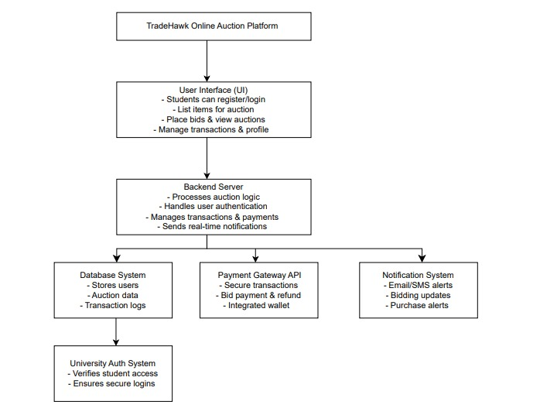

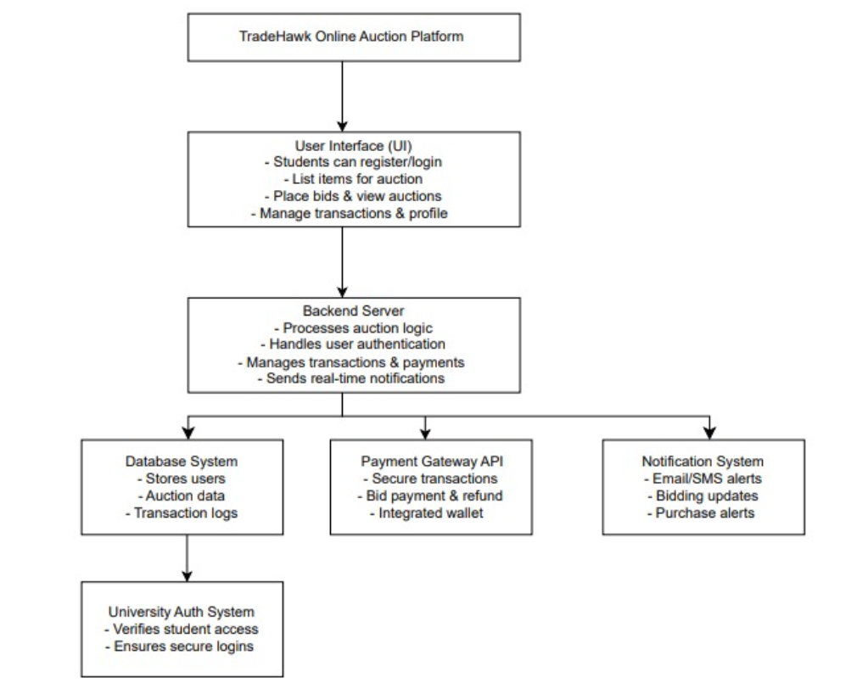

Product Functionality
- User Registration & Authentication: Allows Mahindra University students to create accounts and log in securely using university credentials.
- Auction Listing & Management: Enables users to list, edit, and manage items for auction with product details and starting bid prices.
- Bidding System: Provides real-time bidding where users can place and track bids dynamically.
- Buy & Repurchase Items: Allows winning bidders to complete purchases and enables item repurchase by previous owners.
- Payment & Transaction Processing: Integrates a secure payment gateway for seamless transactions, bid payments, and refunds.
- User Dashboard & Notifications: Displays user-specific auction details and sends real-time notifications for bid status and transactions.
- Search & Filtering Options: Provides advanced search with filters based on category, price range, and item condition.

Design and Implementation Constraints

1. Hardware Constraints
- Device Compatibility: The platform must be optimized for laptops, desktops, and smartphones. If not properly optimized, users with low-end devices may experience slow load times, lag, or inability to access features.
- Server Requirements: The backend must be deployed on a server with sufficient processing power and storage to handle real-time bidding. Inadequate server resources may cause delays in bid processing and crashes during high traffic periods.
- Network Dependency: The system requires a stable internet connection for real-time auctions. Poor network handling could lead to missed bids, failed transactions, or incorrect auction results.

2. Software Constraints
- Technology Stack Restrictions: The development team must use React.js (Frontend), Node.js (Backend), MongoDB & MySQL (Databases), and Express.js (API Framework). Using unapproved technologies may result in compatibility issues, security loopholes, and difficulty in system integration.
- Concurrency Handling: The system must support parallel bidding operations in real-time. If concurrency is not managed properly, users may experience race conditions, bid overwrites, or incorrect auction winners.

3. Security Constraints
- Data Encryption & Privacy Compliance: User data, including personal details and payment information, must be encrypted. Failure to implement proper encryption and data protection mechanisms could lead to data breaches, financial fraud, and legal consequences.
- Secure Payment Integration: Transactions must be processed via a trusted Payment Gateway API with secure encryption. If an insecure payment method is used, users may face payment failures, unauthorized transactions, or financial losses.

4. Regulatory & Compliance Constraints
- University Policies: The platform must comply with Mahindra University’s regulations and guidelines. Failure to do so may result in restricted access, forced shutdown, or rejection by the university administration.

Development Standards:
The software must follow the COMET method for the designing process.
Reference: Gomaa, H. (2011). “Software Modeling and Design: UML, Use Cases, Patterns, and Software Architectures”.
UML, Use Cases, Patterns, and Software Architectures.
Cambridge University Press.

The system design must use the UML (Unified Modeling Language) modeling approach for:
- Use Case Diagrams to define user interactions.
- Class Diagrams for system structure representation.
- Sequence Diagrams to illustrate process flow.
- Reference: Object Management Group (OMG), UML 2.5 Specification

Assumptions and Dependencies

Assumptions
- Fair Bidding Practices Will Be Followed – Users are expected to participate in auctions fairly without bid manipulation, fake bidding, or collusion. If students try to exploit the system, additional security measures may be required.
- Sellers Will Accurately Describe Items – It is assumed that sellers will provide honest descriptions and images of items to maintain transparency. Misrepresentation of products could lead to disputes and reduce user confidence.
- Moderate Transaction Volume Initially – The platform is expected to handle a growing but manageable number of transactions at launch. If demand unexpectedly spikes, scalability issues may arise, requiring infrastructure upgrades.
- Legal and Ethical Use of the Platform – Students are expected to use TradeHawk for legitimate trading within university guidelines. Unauthorized sales of prohibited or counterfeit goods could lead to regulatory challenges.

Dependencies

Frontend Development:
- ReactJS – For building interactive and dynamic user interfaces.
- Next.js – For improved performance, SEO benefits, and optimized rendering.

Backend Development:
- Node.js with Express.js – For efficient API development and request handling.
- Socket.io – For implementing real-time bidding and notification features.

Database Solutions:
- MongoDB Atlas – For scalable cloud-based storage.
- MySQL – For structured data management, such as transaction logs and user data.

UI/UX Design:
- Figma – For designing and prototyping the platform’s user interface.

Specific Requirements

External Interface Requirements

User Interfaces

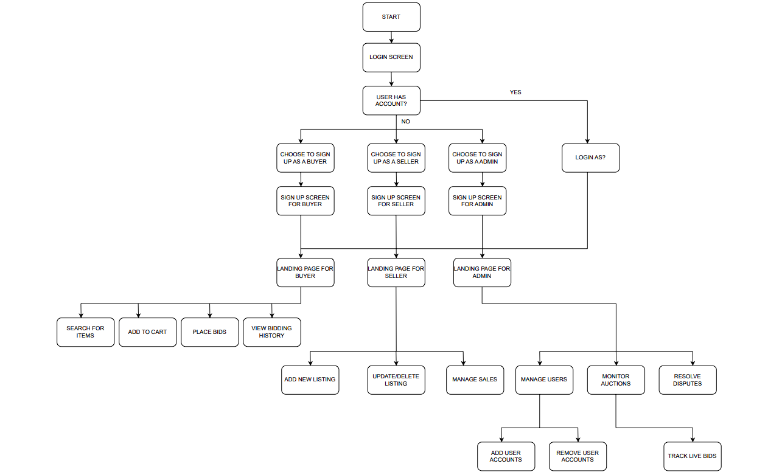

1. Buyer Interface
- Login & Authentication: Buyers log in using their email ID and password with optional two-factor authentication.
- Browse & Search Items: Use filters like price range, categories, and auction status to find desired products.
- Add to Cart: Add items to the cart before placing bids.
- Place Bids: Buyers can place bids directly and receive notifications if they are outbid.
- Track Bids & Orders: View bidding history, track orders, and access payment details from the dashboard.

2. Seller Interface
- Login & Authentication: Sellers log in securely using their credentials.
- List Items: Sellers can create new product listings with images, descriptions, and starting bids.
- Manage Listings: Sellers can edit product details, update prices, or delete listings before any bids are placed.
- Track Sales: Access sales records, buyer details, and payment statuses.
- Re-list Items: Unsold items can be relisted easily with updated details.

3. Administrator Interface
- Login & Authentication: Admins log in with secure credentials to access system controls.
- User Management: Add, disable, or modify user accounts for buyers and sellers.
- Auction Monitoring: Oversee active auctions, pause suspicious listings, and resolve disputes.
- System Settings: Manage auction rules, bidding increments, and promotional content.
- Database Control: Access transaction records, sales reports, and system logs for maintenance and audits.

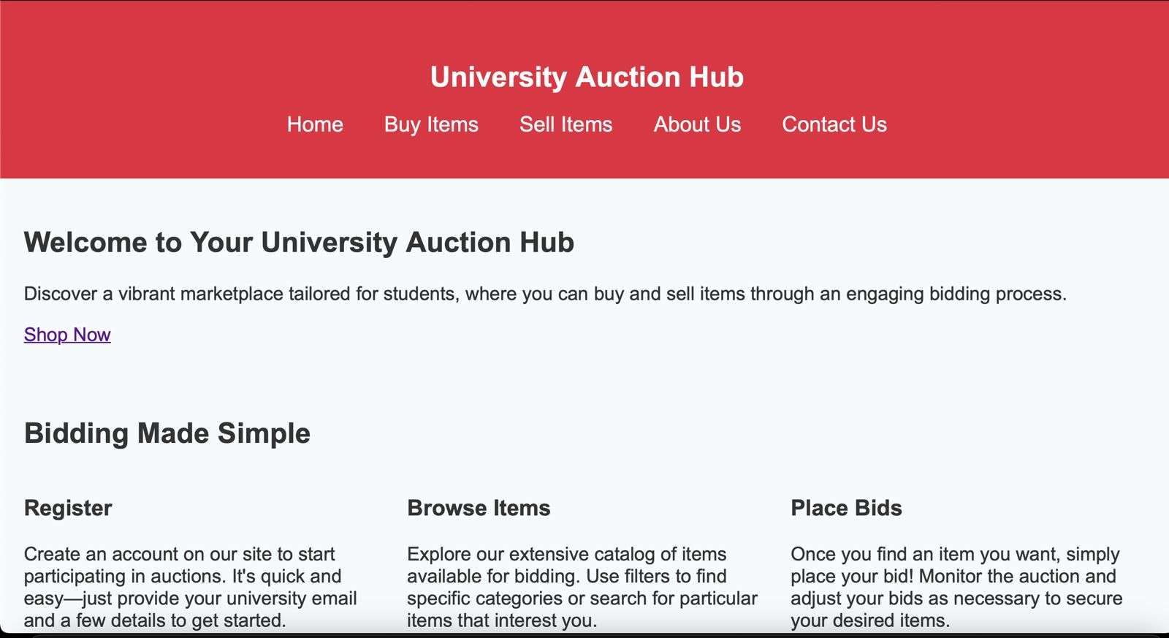

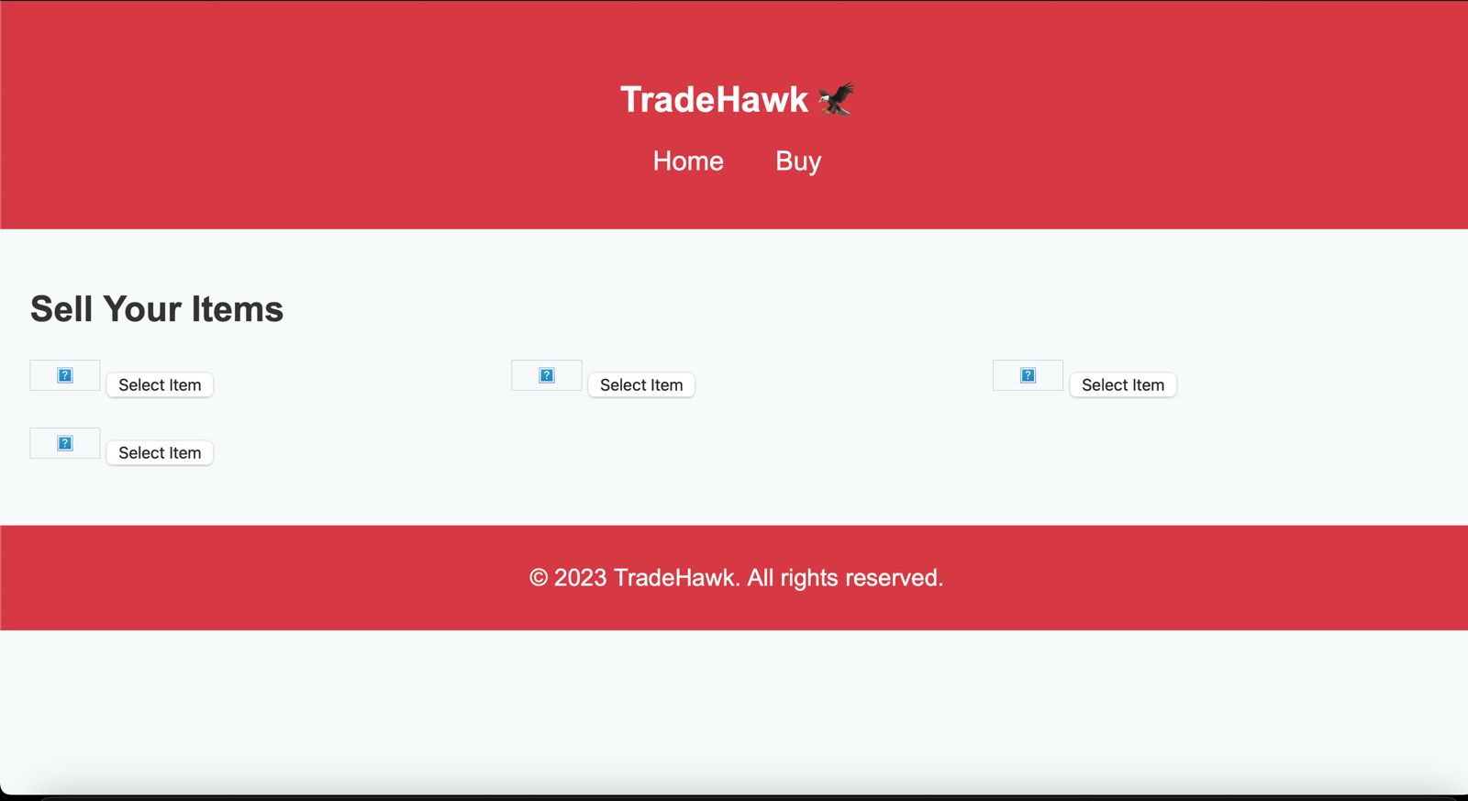

Hardware Interfaces
Buyer Interface

Supported Devices - Personal Computers & Smartphones: Access through a web browser
Hardware Interactions
- Keyboard Input: Buyers can enter credentials to log in, search for items, and place bids.
- Printers: Buyers can print transaction receipts or item details.
- Display Screen: Displays auction listings, bid status, and payment confirmation.
Communication Protocols
- HTTP/HTTPS: Ensures secure communication between the buyer’s device and the TradeHawk web platform.
- WebSocket Protocol: Facilitates real-time updates for bidding status and auction progress.

Seller Interface

Supported Devices - Personal Computers & Smartphones: Access through a web browser
Hardware Interactions
- Keyboard Input: Sellers can enter item details, manage listings, and view bidding updates.
- Printers: Sellers can print transaction details or item history if needed.
- Display Screen: Shows item listing status, bid updates, and sales details.
Communication Protocols
- HTTP/HTTPS: Ensures secure data transmission for item listings, sales updates, and account management.
- WebSocket Protocol: Supports real-time auction updates and notification alerts.

Administrator Interface

Supported Devices - Admin Workstations: Secure systems within authorized environments
Secure Servers: Backend management for system monitoring and data integrity
Hardware Interactions
- Server Console Access: Admins may access backend servers for maintenance, monitoring, and dispute resolution.
- Keyboard Input: Admins can manage users, auctions, and security protocols.
- Display Screen: Displays system logs, user activities, and performance analytics.
Communication Protocols
- SSH (Secure Shell): Provides secure remote access for server maintenance.
- HTTPS: Ensures encrypted communication for admin panel access.
- FTP/SFTP: Used for secure file transfer and database management.

Software Interfaces
1. Website Interface
- Users (Buyers, Sellers, and Admins) interact with the platform through a responsive web application.
- The website facilitates key actions like:
  - User Authentication: Secure login system for Buyers, Sellers, and Admins.
  - Auction Management: Buyers place bids, Sellers manage listings, and Admins oversee auction activities.
  - Transaction Handling: Secure payment gateway integrated for processing transactions efficiently.
- Data exchange with the backend occurs via encrypted API requests for improved security.

2. API Integration
TradeHawk utilizes secure APIs to manage critical functionalities such as:
- User Profile Management: Users can update profiles, track orders, and manage listings securely.
- Auction Operations: APIs manage listing creation, bid placements, and auction closing.
- Payment Gateway Integration: Ensures secure transactions for item purchases and sales..

3. Authentication & Authorization
Role-based access controls ensure secure platform management:
- Buyers: Can place bids, view item details, and track purchases.
- Sellers: Can list items, manage active auctions, and track sales.
- Admins: Have elevated privileges to manage user accounts, monitor activities, and resolve disputes.

4. Database Integration
The platform uses:
- MongoDB Atlas: For cloud-based data storage ensuring scalability and security.
- MySQL: For structured data handling and complex queries for auctions and transactions.

5. Notification System
TradeHawk integrates email and push notification services to:
- Alert buyers on bid status changes.
- Notify sellers about successful sales or new offers.
- Update admins on platform security alerts or disputes.

Functional Requirements
3.2.1 F1: Auction Listing & Management
- The system shall allow users to list items for auction, providing product descriptions, images, and starting bid prices.
- The system shall allow sellers to edit or delete their auction listings before a bid is placed.
- The system shall automatically mark items as “Sold” once an auction ends and a bid is accepted.
- The system shall allow sellers to set auction duration, after which the bidding automatically closes.

3.2.2 F2: Bidding System
- The system shall allow users to place bids on auctioned items in real-time.
- The system shall prevent users from placing bids lower than the current highest bid.
- The system shall update the auction in real-time, showing the highest bid instantly.
- The system shall notify users if they have been outbid, allowing them to increase their bid.
- The system shall close bidding automatically when the auction duration ends, awarding the item to the highest bidder.

3.2.3 F3: Buy & Repurchase Items
- The system shall allow the highest bidder to complete the transaction after winning an auction.
- The system shall provide a payment deadline for the buyer, after which the item can be relisted if the purchase is not completed.
- The system shall allow sellers to repurchase previously sold items, enabling a secondary marketplace.
- The system shall allow users to track their purchased and repurchased items in their dashboard.

3.2.4 F4: User Dashboard & Notifications
- The system shall provide a user dashboard that displays their active bids, listed items, and purchase history.
- The system shall send real-time notifications when a bid is placed, outbid, won, or when an auction is ending.
- The system shall send users an email confirmation when they win an auction or complete a payment.
- The system shall allow users to customize notification settings to control what updates they receive.

3.2.5 F5: Search & Filtering Options
- The system shall allow users to search for auction items using keywords.
- The system shall provide filters based on category, price range, auction status, and item condition.
- The system shall allow users to sort auction listings by newest, ending soon, or highest bid.

3.2.6 F6: Wishlist & Watchlist
- The system shall allow users to save auction items to a watchlist for later bidding.
- The system shall notify users if an item in their watchlist is about to end.

Use Case Model

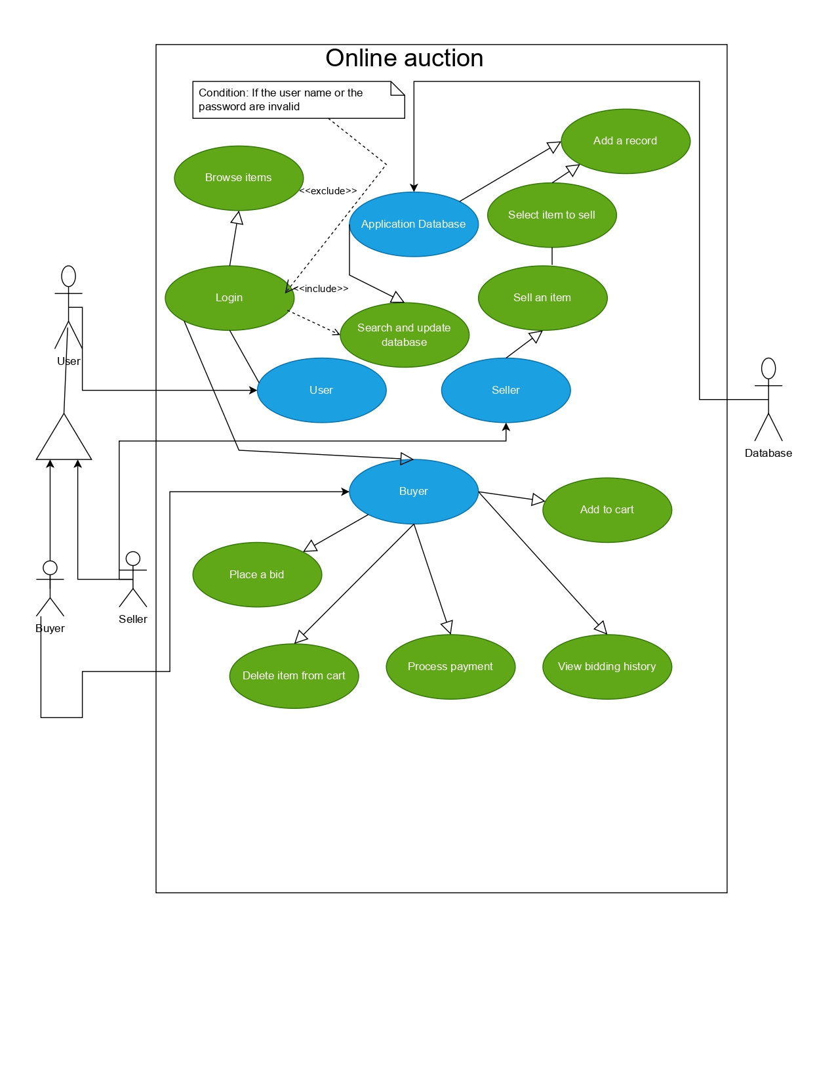

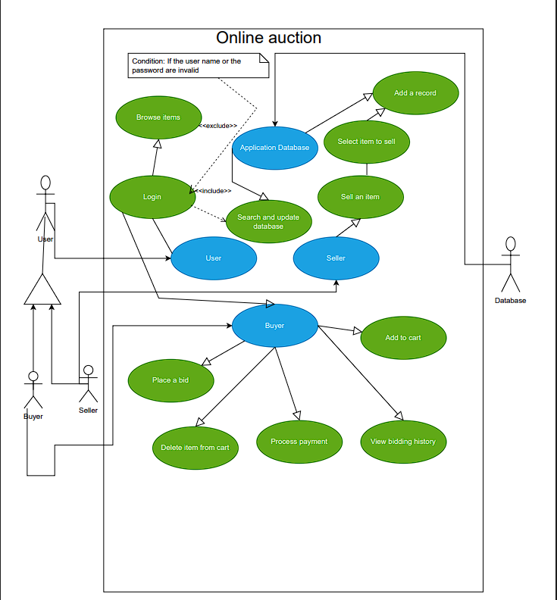

Use Case #1: U1 - Payment Processing

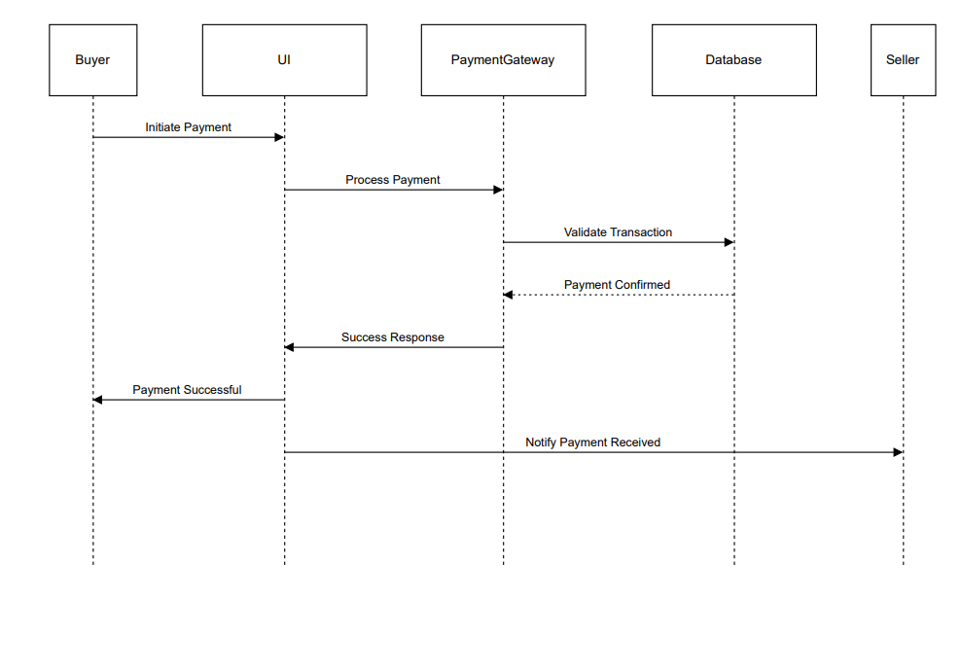

Author: Harshdeep(SE22UCSE108)

Purpose:

This use case describes the process of handling a payment transaction between a buyer and a seller through a payment gateway and database validation.

Requirements Traceability:

The system must allow secure payment processing.

Payments should be validated before confirmation.

The seller should receive a notification upon successful payment.

Priority: High

Ensuring smooth payment processing is critical to system functionality.

Preconditions:

The buyer must have selected items for purchase.

A valid payment method must be available.

The system must be online and accessible.

Postconditions:

The payment is either successfully completed, or an error message is displayed.

The buyer is notified of the payment result.

The seller is informed of successful payment.

Actors:

Buyer UI (Initiates payment)

Payment Gateway (Processes and validates payment)

Database (Stores transaction details)

Seller (Receives payment confirmation)

Extends: None

Flow of Events

Basic Flow:

Buyer initiates a payment request.

The payment gateway processes the transaction.

The system validates the transaction details against the database.

If valid, the payment is confirmed.

A success response is sent to the buyer.

The seller is notified of the successful payment.

Alternative Flow:

If the payment gateway takes longer than expected, a retry mechanism may be triggered.

Exceptions:

Invalid Payment Details: The transaction is declined, and an error message is displayed.

Database Unavailable: Payment processing is delayed or fails, prompting the buyer to retry.

Insufficient Funds: The transaction fails, and the buyer is notified.

Includes: None

Notes/Issues:

Need to confirm timeout handling in case of payment gateway failure.

Use Case #2: U2 - Auction Completion & Winner Notification

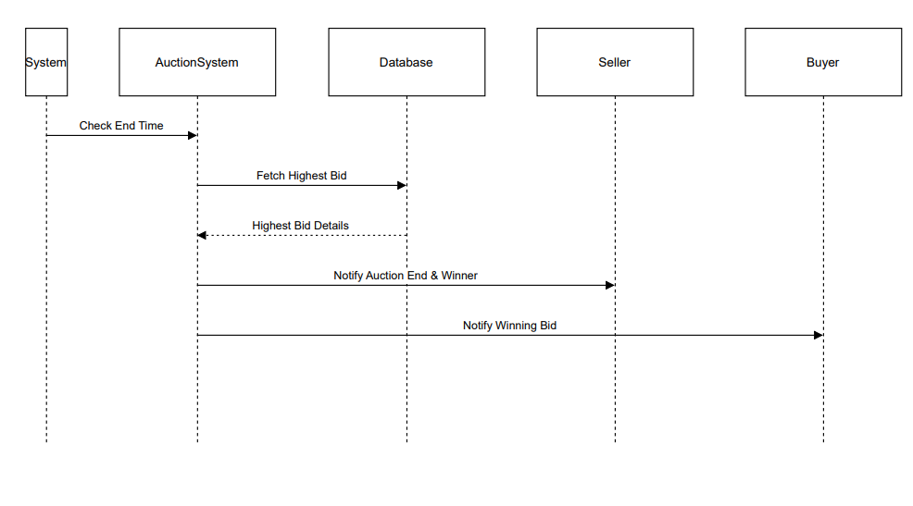

Author : Adarsh Ladi(Se22ucse304)

Purpose:

This use case defines the process of finalizing an auction by checking the auction end time, determining the highest bid, and notifying the relevant participants.

Requirements Traceability:

The system should automatically check when an auction ends.

The highest bid should be fetched and stored.

The system should notify the seller and the winning bidder.

Priority: High

Ensuring proper auction finalization is crucial for system reliability and user satisfaction.

Preconditions:

An auction must have been created and active.

Bids must have been placed.

The system clock must be functional and correctly synchronized.

Postconditions:

The auction is marked as completed.

The highest bid details are recorded.

The winner and seller are notified.

Actors:

System (Triggers auction end check)

Auction System (Fetches highest bid and processes winner notification)

Database (Stores bid details and auction status)

Seller (Receives auction results)

Buyer (Winning bidder is notified)

Extends: None

Flow of Events

Basic Flow:

The system checks if an auction's end time has been reached.

The auction system fetches the highest bid from the database.

The highest bid details are validated and stored.

The seller is notified of the auction result.

The winning buyer is notified of their successful bid.

Alternative Flow:

If no valid bids exist, the seller is notified that the auction ended without a winner.

Exceptions:

Database Unavailable: The auction cannot be finalized, triggering a retry or manual resolution.

System Time Sync Issue: The auction might not end at the correct time, requiring manual intervention.

Includes: None

Notes/Issues:

Clarify handling of auctions with no valid bids.

Ensure time synchronization across auction events.

Use Case #3: U3 - Item Listing for Auction

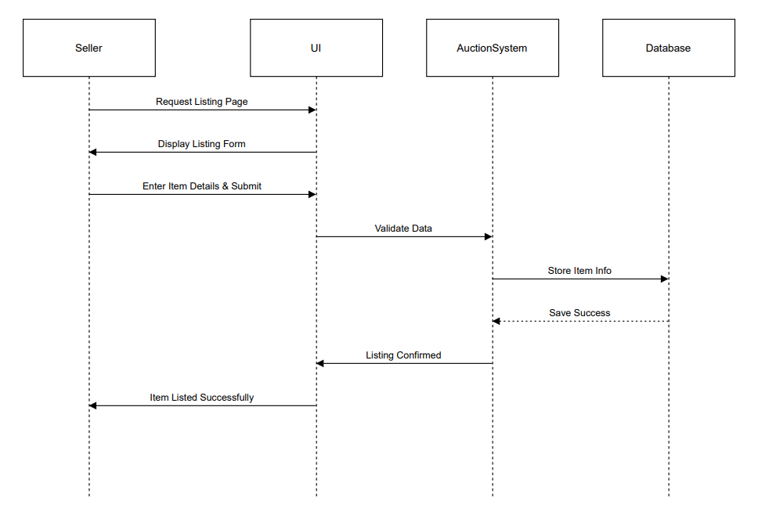

Author: KTS Satwik Reddy(SE22UCSE122)

Purpose:

This use case describes the process of a seller listing an item for auction by entering details, validating data, and storing it in the database.

Requirements Traceability:

The system should provide a listing page for sellers.

The entered item details should be validated before storage.

The item should be successfully listed in the auction system.

Priority: High

Item listing is essential for auction functionality.

Preconditions:

The seller must be logged into the system.

The auction system must be operational.

The database must be accessible.

Postconditions:

The item is successfully listed for auction.

The seller receives a confirmation.

Actors:

Seller UI (Initiates item listing)

Auction System (Processes and validates item details)

Database (Stores the item listing information)

Extends: None

Flow of Events

Basic Flow:

The seller requests the listing page.

The system displays the item listing form.

The seller enters item details and submits the form.

The auction system validates the data.

If valid, the item information is stored in the database.

A success message is displayed, confirming the listing.

Alternative Flow:

If validation fails, an error message is displayed, and the seller must correct the input.

Exceptions:

Database Unavailable: The item cannot be stored, and an error message is displayed.

Invalid Data Entry: The seller is prompted to correct missing or incorrect details.

Includes: None

Notes/Issues:

Need to ensure required fields are clearly indicated in the listing form.

Consider adding image upload functionality for item listings.

Use Case #4: U4 - User Login Authentication

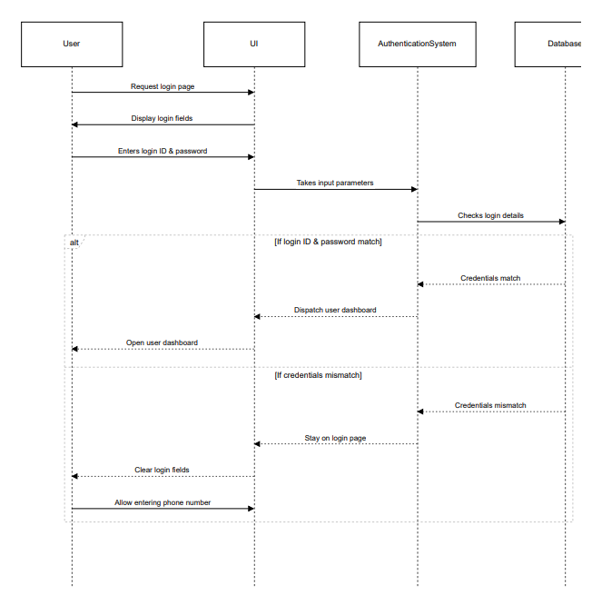

Author: G Nikhilesh(SE22UCSE098)

Purpose:

This use case describes the process of user authentication, including verifying login credentials and handling success or failure scenarios.

Requirements Traceability:

The system must validate user login credentials securely.

Users should be redirected to their dashboard upon successful authentication.

Users must be given an option to re-enter credentials if authentication fails.

Priority: High

User authentication is essential for secure system access.

Preconditions:

The user must have registered an account.

The authentication system must be functional.

The database containing user credentials must be accessible.

Postconditions:

If login is successful, the user accesses their dashboard.

If login fails, the user is prompted to re-enter credentials or use alternative authentication methods.

Actors:

User UI (Initiates login request)

Authentication System (Processes and verifies credentials)

Database (Stores and retrieves user login details)

Extends: None

Flow of Events

Basic Flow:

The user requests the login page.

The system displays login fields.

The user enters their login ID and password.

The authentication system takes input parameters and verifies the credentials.

If credentials match, the user dashboard is dispatched.

The user gains access to their dashboard.

Alternative Flow:

If the credentials do not match, the system clears the login fields and allows the user to re-enter their credentials or use an alternative authentication method.

Exceptions:

Database Unavailable: Authentication cannot proceed, and an error message is displayed.

Incorrect Credentials: The system prompts the user to re-enter valid credentials.

Multiple Failed Attempts: The system may lock the account or request additional verification.

Includes: None

Notes/Issues:

Consider implementing multi-factor authentication for added security.

Need to define a mechanism for handling account lockouts after repeated failed login attempts

Use Case #5: U5 - Order Shipment & Delivery Tracking

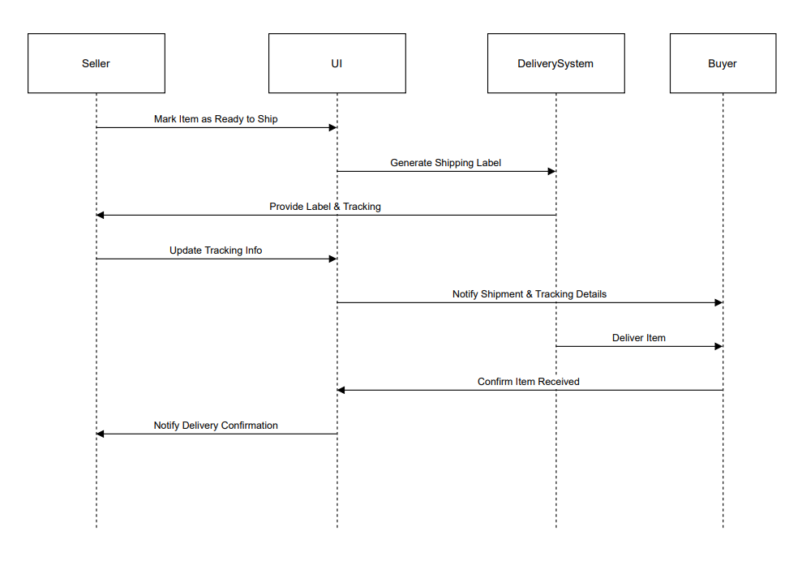

Author: Amith Reddy(SE22UCSE266)

Purpose:

This use case describes the process of shipping an ordered item, generating tracking information, and notifying the buyer upon successful delivery.

Requirements Traceability:

Sellers must be able to mark an item as ready for shipment.

A shipping label and tracking details should be generated and provided to the buyer.

Buyers should receive real-time updates on shipment and delivery status.

Priority: High

Ensuring smooth order fulfillment and shipment tracking is critical to user experience and trust in the system.

Preconditions:

The buyer must have successfully placed and paid for an order.

The seller must have prepared the item for shipment.

The delivery system must be operational.

Postconditions:

The item is shipped, and the buyer receives tracking details.

The delivery system updates tracking status in real time.

The buyer receives confirmation once the item is delivered.

Actors:

Seller UI (Initiates shipment process)

Delivery System (Manages shipping and tracking updates)

Buyer (Receives tracking details and confirms delivery)

Extends: None

Flow of Events

Basic Flow:

The seller marks the item as ready for shipment.

The delivery system generates a shipping label and tracking number.

The system provides the shipping label and tracking details to the seller.

The tracking information is updated in the system.

The buyer is notified with shipment details.

The delivery system delivers the item to the buyer.

The buyer confirms receipt of the item.

The system notifies the seller of successful delivery.

Alternative Flow:

If the tracking information fails to update, the system retries after a predefined interval.

Exceptions:

Delivery System Failure: Shipping label generation may be delayed, requiring manual intervention.

Incorrect Tracking Details: The system prompts the seller to verify and re-enter the correct details.

Buyer Unavailable for Delivery: The delivery system schedules a reattempt or requests alternate delivery instructions.

Includes: None

Notes/Issues:

Need to confirm integration with third-party shipping carriers.

Consider implementing automated notifications for delivery delays.

Use Case #6: U6 - Auction Winner Notification

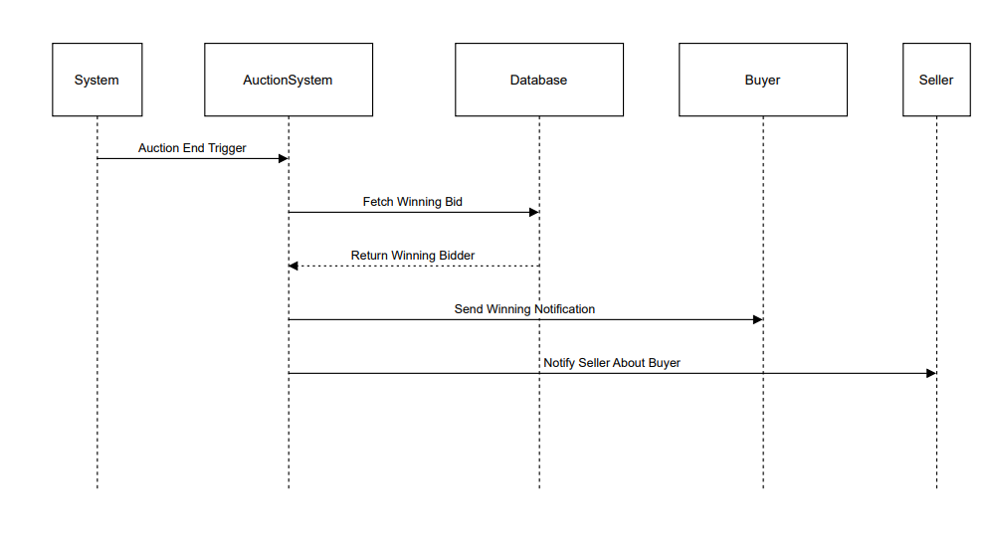

Author: K Karthik Reddy(SE22UCSE128)

Purpose:

This use case describes the process of determining the auction winner and notifying both the buyer and the seller.

Requirements Traceability:

The system must detect when an auction has ended.

The highest bid should be fetched and the winning bidder identified.

Notifications must be sent to both the buyer and the seller.

Priority: High

Auction winner notification is crucial for ensuring smooth order fulfillment.

Preconditions:

An auction must have been completed.

The system must have recorded valid bids.

The database storing auction results must be available.

Postconditions:

The system successfully identifies and notifies the winning bidder.

The seller is informed about the auction results.

Actors:

System (Triggers auction end and determines the winner)

Auction System (Processes the highest bid and handles notifications)

Database (Stores bidding information and winning results)

Buyer (Receives notification if they have won the auction)

Seller (Gets notified about the winning buyer)

Extends: None

Flow of Events

Basic Flow:

The system detects that the auction end time has been reached.

The auction system fetches the highest bid from the database.

The system determines the winning bidder and confirms their bid.

A winning notification is sent to the buyer.

The seller is informed about the winning bidder.

Alternative Flow:

If no bids exist, the system notifies the seller that the auction ended without a winner.

Exceptions:

Database Unavailable: The winning bid cannot be fetched, delaying notification.

System Failure: Auction results may be delayed, requiring manual intervention.

Includes: None

Notes/Issues:

Ensure the auction end time is synchronized accurately.

Define a retry mechanism for failed notifications.

Use Case #7: U7 - User Login Authentication

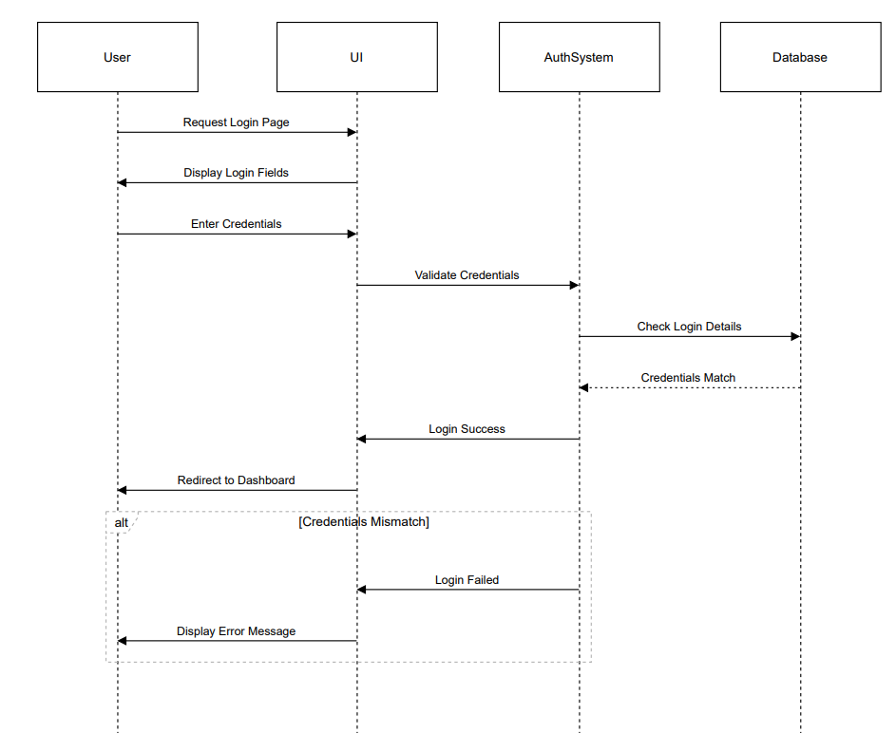

Author: EVM Teja(SE22UCSE091)

Purpose:

This use case describes the process of authenticating a user by validating login credentials and handling both success and failure scenarios.

Requirements Traceability:

The system must validate user login credentials securely.

Users should be redirected to their dashboard upon successful authentication.

Users must be given an option to re-enter credentials if authentication fails.

Priority: High

User authentication is essential for secure system access.

Preconditions:

The user must have an existing registered account.

The authentication system must be operational.

The database containing user credentials must be accessible.

Postconditions:

If login is successful, the user is redirected to their dashboard.

If login fails, the user is prompted to re-enter credentials or is shown an error message.

Actors:

User UI (Initiates login request)

Auth System (Processes and verifies credentials)

Database (Stores and retrieves user login details)

Extends: None

Flow of Events

Basic Flow:

The user requests the login page.

The system displays the login fields.

The user enters their credentials (username and password).

The authentication system validates the credentials by checking the database.

If the credentials match, the system grants access and redirects the user to their dashboard.

Alternative Flow:

If credentials do not match, the system displays an error message and prompts the user to re-enter credentials.

Exceptions:

Database Unavailable: Authentication cannot proceed, and an error message is displayed.

Incorrect Credentials: The system prompts the user to re-enter valid credentials.

Multiple Failed Attempts: The system may temporarily lock the account or request additional verification.

Includes: None

Notes/Issues:

Consider implementing multi-factor authentication for added security.

Define a mechanism for handling account lockouts after repeated failed login attempts.

Use Case #8: U8 - Placing a Bid on an Auction Item

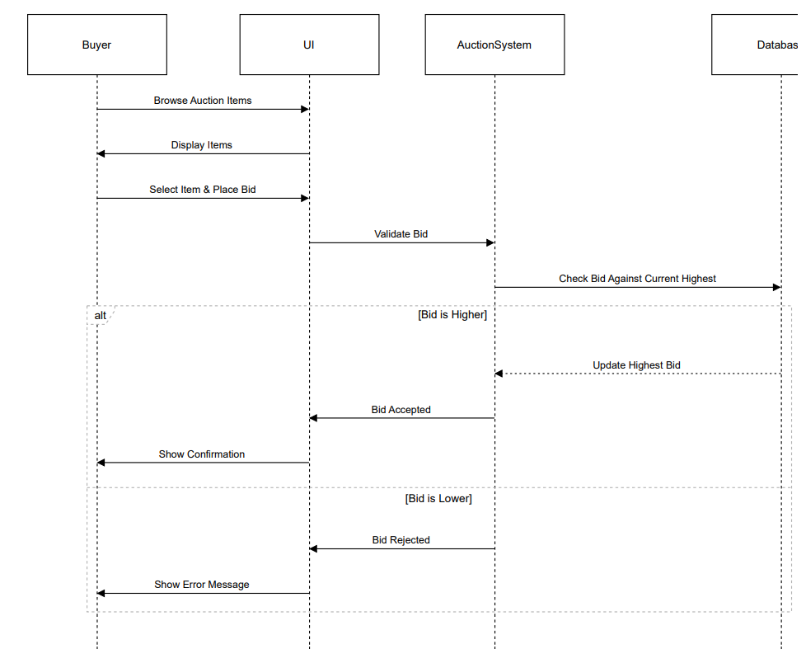

Author: Karthik Kumar Reddy(SE22UCSE276)

Purpose:

This use case describes the process of a buyer browsing auction items, placing a bid, and receiving confirmation or rejection based on bid validation.

Requirements Traceability:

Buyers should be able to view and select auction items.

The system must validate the bid amount before submission.

If the bid is higher than the current highest bid, it should be accepted and updated in the database.

If the bid is lower, the buyer should receive an error message.

Priority: High

Ensuring correct bid validation and updating the highest bid is essential for a fair auction process.

Preconditions:

The buyer must be logged into the system.

The auction system must have active listings.

The database storing bid information must be accessible.

Postconditions:

If the bid is accepted, it becomes the new highest bid.

If the bid is lower than the current highest, it is rejected.

The buyer receives appropriate feedback (confirmation or error message).

Actors:

Buyer UI (Initiates the bidding process)

Auction System (Validates and updates bid information)

Database (Stores and manages auction bids)

Extends: None

Flow of Events

Basic Flow:

The buyer browses auction items.

The system displays available auction listings.

The buyer selects an item and places a bid.

The auction system validates the bid.

The system checks if the bid is higher than the current highest bid.

If the bid is higher:

The system updates the highest bid in the database.

The buyer receives a confirmation message.

Alternative Flow:

If the bid is lower than the current highest bid:

The system rejects the bid.

An error message is displayed to the buyer.

Exceptions:

Database Unavailable: Bids cannot be validated or stored, prompting an error message.

Bid Entry Error: If an invalid bid amount is entered, the system requests correction.

Includes: None

Notes/Issues:

Consider adding an automatic notification system to inform buyers when they are outbid.

Define a mechanism for bid increment rules to avoid unrealistic bid values.

Other Non-functional Requirements

4.1Performance Requirements
P1. User Authentication Response Time

The system must authenticate users within 2 seconds upon entering valid credentials.
Rationale: Ensures a smooth login experience and prevents delays in accessing auction features.

P2. Auction Listing Load Time

The platform should display auction listings within 3 seconds of a user accessing the marketplace.
Rationale: Reduces user wait time and enhances engagement.

P3. Real-time Bidding Update

The auction system must reflect new bids within 1 second of placement.
Rationale: Ensures real-time accuracy in competitive bidding.

P4. Search and Filtering Response

When a user applies filters or searches for an item, results must be displayed within 2 seconds.
Rationale: Enhances the browsing experience and improves usability.

P5. Payment Processing

The system must complete payment verification and transaction processing within 5 seconds.
Rationale: Ensures a smooth and fast checkout experience while maintaining security.

P6. Item Upload and Listing Confirmation

When a seller lists an item, confirmation should be received within 3 seconds.
Rationale: Provides immediate feedback to the user and ensures successful listing.
P7. Notification Delivery

Notifications for outbid alerts, auction closing, or successful purchases must be sent within 2 seconds.
Rationale: Keeps users informed in real time.

P8. Maximum Concurrent Users Support

The system should be able to handle at least 500 concurrent users without performance degradation.
Rationale: Ensures stability and accessibility during peak auction times.

P9. Data Consistency and Synchronization

Database updates (e.g., bid placements, item availability) must be reflected across all users within 2 seconds.
Rationale: Prevents discrepancies in auction status.

P10. System Uptime

The platform must maintain 99.5% uptime, ensuring minimal service disruptions.
Rationale: Guarantees high availability for users.

4.2Safety and Security Requirements
1.User Identity Authentication

Requirement: Implement a robust authentication mechanism to ensure that only authorized Mahindra University students can access the platform.

Safeguards:
- Require users to register using their official university email addresses.
- Implement multi-factor authentication (MFA), combining passwords with OTPs sent to registered mobile numbers.

Rationale: Prevents unauthorized access and ensures that only legitimate users participate in the platform's activities.

2.Data Protection Compliance

Requirement: Ensure that the collection, storage, and processing of personal data comply with the Digital Personal Data Protection Act, 2023.

Safeguards:
- Obtain explicit consent from users before collecting personal data.
- Allow users to access, correct, and delete their personal data upon request.
- Implement data minimization principles, collecting only necessary information.

Rationale: Adherence to legal requirements protects user privacy and builds trust in the platform.

Secure Data Transmission

Requirement: Protect data in transit to prevent interception or tampering.
Safeguards:
- Use SSL/TLS protocols to encrypt data transmitted between users and the platform.
- Regularly update and patch security protocols to address emerging threats.

Rationale: Ensures the confidentiality and integrity of user data during transmission.

3.Third-Party Data Sharing Restrictions

Requirement: Prohibit sharing user data with third parties without explicit consent.

Safeguards:
- Clearly communicate data sharing policies to users during registration.
- Provide users with options to opt-in or opt-out of data sharing agreements.

Rationale: Respects user privacy and complies with data protection regulations.

4.Compliance with External Policies and Regulations

Requirement: Ensure that the platform's operations align with relevant external policies and regulations.

Safeguards:
- Stay updated on changes to data protection laws and industry standards.
- Conduct regular compliance assessments and adjust policies accordingly.

Rationale: Avoids legal penalties and enhances the platform's credibility.

5.Safety Certifications

Requirement: Obtain relevant safety and security certifications to demonstrate commitment to user protection.

Safeguards:
- Pursue certifications such as ISO/IEC 27001 for information security management.

Rationale: Provides assurance to users and stakeholders about the platform's security posture.

4.3Software Quality Attributes

4.3.1 Reliability
Requirement: The platform shall maintain 99.5% uptime, ensuring it is available for users at all times except during scheduled maintenance.

Implementation Approach:
- Use cloud-based hosting with auto-scaling to handle varying loads.
- Implement database replication to ensure high availability.

4.3.2Adaptability

Requirement: The system must be designed to support future enhancements such as new payment methods, additional product categories, and extended user roles.

Implementation Approach:
- Use a modular architecture so that components (e.g., auction system, payment gateway) can be replaced or extended without major changes.
- Ensure the database schema is flexible to accommodate new product types.
- Use API-driven development so external services can be integrated easily.

Verification: New features will be tested in a staging environment before deployment to production.

4.3.3 Usability

Requirement: The platform should provide an intuitive and easy-to-use interface, ensuring users can complete key actions (e.g., placing bids, listing items) within three clicks.

Implementation Approach:
- Conduct user testing with Mahindra University students to refine navigation.
- Implement consistent UI elements with clear labels and tooltips.
- Follow WCAG 2.1 accessibility guidelines to support all users, including those with disabilities.

Verification: Conduct usability testing with students and gather feedback to improve navigation and accessibility.

4.3.4 Maintainability

Requirement: The codebase should be structured to allow quick debugging and updates, with new features being added within two weeks of requirement gathering.

Implementation Approach:
- Follow clean code principles and use well-documented APIs.
- Implement version control with Git, ensuring rollback capabilities in case of issues.

Verification: Perform code reviews and track issue resolution time to measure maintainability.

4.3.5Portability

Requirement: The platform should be accessible from multiple devices and operating systems, including desktops, laptops, tablets, and mobile phones.

Implementation Approach:
- Develop using responsive web design principles to ensure compatibility across screen sizes.
- Ensure the system works across major browsers (Chrome, Firefox, Edge, Safari).
Verification: Conduct cross-device and cross-browser testing to ensure seamless performance on different platforms.

4.3.6Robustness

Requirement: The system should handle unexpected errors gracefully without affecting core functionality.

Implementation Approach:
- Implement comprehensive error handling to prevent system crashes.
- Use database transaction rollback mechanisms to avoid data corruption.

Verification: Perform stress testing and fault injection testing to assess system stability under adverse conditions.

Appendix A – Data Dictionary

Name | Type | Description | Possible Values/Format | Related Operations/Requirements
User_ID | String | Unique identifier for each user | Username@xxxx | User Registration & Authentication (F1)
Username |  | User’s chosen name | Alphanumeric (max 20 chars) | User Registration & Authentication (F1)
  String
Email |  | User’s email address (university-verified) | Valid email format | User Registration (F1)
  String
Password |  |  | Hashed string | User Authentication (F1)
  String
  Encrypted password for authentication
User_Role |  | Defines user type | Buyer, Seller, Admin | User Access Control (F1)
  Enum
Auction_ID | Integer | Unique identifier for an auction | Auto-incremented | Auction Listing & Management (F2)
Item_Name | String | Name of the item being auctioned | Alphanumeric (max 50 chars) | Auction Listing (F2)
Item_Description | String |  | Text (max 500 chars) | Auction Listing (F2)
  Detailed description of the item
Item_Condition | Enum | Condition of the item | New, Used, Like New | Auction Listing (F2)
Starting_Bid | Float | Initial price of the auctioned item | Currency format | Auction Listing (F2)
Current_Bid | Float | Highest bid placed on an item | Currency format | Bidding System (F3)
Bidder_ID | Integer | User ID of the highest bidder | Foreign key to User_ID | Bidding System (F3)
Bid_Amount | Float | Amount placed by a bidder | Currency format | Bidding System (F3)
Auction_Status | Enum |  | Active, Closed, Sold | Auction Management (F2)
  Status of the auction
Auction_EndTime | Timestamp | Time when the auction ends | Date-Time format | Auction Listing (F2)
Transaction_ID | Integer |  | Auto-incremented | Payment & Transaction Processing (F4)
  Unique identifier for each transaction
Buyer_ID | Integer | User ID of the buyer | Foreign key to User_ID | Payment & Transaction Processing (F4)
Seller_ID | Integer | User ID of the seller | Foreign key to User_ID | Payment & Transaction Processing (F4)
Transaction_Status | Enum | Status of the transaction | Pending, Completed, Failed | Payment & Transaction Processing (F4)
Payment_Method | Enum |  | Credit Card, Wallet, UPI | Payment & Transaction Processing (F4)
  Method used for payment
Notification_ID | Integer | Unique identifier for a notification | Auto-incremented | Notifications & Alerts (F5)
Notification_Type | Enum | Type of notification | Outbid, Win, Payment Alert | Notifications & Alerts (F5)
Search_Filter | String | User-applied filters for searching items | Category, Price, Status | Search & Filtering (F6)
Watchlist_ID | Integer |  | Auto-incremented | Wishlist & Watchlist (F6)
  Unique identifier for a user’s watchlist item

Appendix B - Group Log
Date | Attendees | Discussion Topics | Time Spent | Assigned Tasks
03.03.25 | G.NIKHILESH  K.KARTHIK REDDY  KTS SATWIK REDDY  KARTHIK KUMAR REDDY  AMITH REDDY  L.ADARSH  T. HARSHDEEP  EVM TEJA | SRS sections assigned, formatting, content finalization | 120-150min | 1.1-1.3 -  KARTHIKKUMAR REDDY  1.4-1.6 -  KTS SATWIK REDDY  2.1-2.2 –  G Nikhilesh  EVM TEJA  2.3-2.4 -  AMITH REDDY  3.1-3.2 -  K Karthik Reddy,  G Nikhilesh  3.3 -  Every Team Member for each use case  4.1 –  T Harshdeep  4.2,4.3 –  G Nikhilesh  Adarsh Ladi
06.03.25 | G.NIKHILESH  K.KARTHIK REDDY  KTS SATWIK REDDY  KARTHIK KUMAR REDDY  AMITH REDDY  L.ADARSH  T. HARSHDEEP  EVM TEJA | Review of functional requirements, data dictionary | 140-160min | Review of Fucntional Requirements –  G Nikhilesh  K Karthik Reddy  Data Dictionary –  K Karthik Reddy  G Nikhilesh
12.03.25 | G.NIKHILESH  K.KARTHIK REDDY  KARTHIK KUMAR REDDY  AMITH REDDY  L.ADARSH  T. HARSHDEEP  EVM TEJA | Final proofreading and submission | 130-150min | EVM Teja  Amith Reddy  T Harshdeep,  Karthik Kumar Reddy,  Adarsh Ladi

